Appendix B
In-Circuit Serial Programming

Overview
Introduction |  | This appendix describes how to design a circuit to support In-circuit Serial Programming (ICSP™). In this appendix, only high voltage programming will be addressed.
In this section |  | Following is a list of topics in this section:
 | Description |  | See Page
 | Programming PICs |  | 2
 | In-Circuit Programming Requirements |  | 4
 | Circuit Considerations |  | 5
 | Implementation |  | 6

Programming PICs
Introduction | The PIC microcontroller is programmed by applying serial data to the part. In this section, we will examine what is required to program a PIC.
Participating pins | All PIC microcontrollers are programmed using pins of the same name. Three pins are always involved (in addition to V_{dd} and V_{ss}); on some newer PIC models, a fourth pin may be required.  - MCLR controls the high voltage programming mode  - A clock signal is provided on RB6  - Programming data is sent on RB7  - On models supporting Low Voltage Programming (LVP), RB3 (RB4 on 18 and 20 pin parts) must be held low to enable high voltage programming  The PIC16F84A supports only high voltage programming, so the state of RB3/4 is unimportant.  The following are the pins involved:  Notice that the 28 pin DIP parts are always “skinny DIP” parts with 300 mil spacing instead of the more common 600 mil spacing.  Parts requiring 40 pins are available in QFN and TQFP (and sometimes PLCC) packages rather than SOIC or SSOP packages.
  Package | PDIP/SOIC  18 | SSOP  20 | SDIP/SOIC  28 | PDIP  40
  MCLR (HVP) | 4 | 4 | 1 | 1
  RB3/4 (PGM) | 10 | 11 | 24 | 36
  RB6 (PGC) | 12 | 13 | 27 | 39
  RB7 (PGD) | 13 | 14 | 28 | 40
 | Continued on next page
Programming PICs, Continued
The programming sequence | For high voltage programming, a specific sequence must be followed. First, the MCLR pin must be brought low (less than one volt). This resets the processor causing all the pins to become inputs.  MCLR must then be quickly raised to the high voltage programming voltage of approximately 12 volts. The exact voltage depends on the particular part. In all cases this voltage must be less than 15 volts. 12.1 volts is adequate in all cases, but for many processors, 9 volts is sufficient. During this time, RB6 and RB7 must be held low.  How quickly MCLR must be raised depends on a number of factors. In all cases, four clock cycles are available for this to happen. In many cases, considerably more time can be taken. It is important that MCLR does not spend enough time between one and nine volts for the program to start. The amount of time it takes for the program to start depends on the type of oscillator and setting of the configuration bits prior to programming.  After a 1 millisecond delay, RB6 is raised and data may be placed on RB7. After a 100 nanosecond delay, RB6 is lowered to clock the data bit into the PIC. After another 100 nanosecond delay, RB6 may be raised and the process repeated for the next data bit.  The data sent to the PIC during programming is actually a sequence of commands which may include data to load into the PIC. At the completion of each command an additional delay is required to allow the PIC to execute the command. Depending on the command, this delay may be between one microsecond and eight milliseconds.
Programming Instructions | There are a number of instructions that are sent to the PIC when it is in program mode. These include things like “set the address to program”, “here is some data”, “program the data I’ve sent you”, “erase the PIC”, and “tell me what is in this memory cell”.  There are some differences between PICs, so as a result, not all software can program all PICs. It can sometimes be difficult to tell whether a specific application can program a particular PIC. For example, in general, ‘A’ parts program differently than “non-A” parts, so while FPP can program a 16F877 it cannot program a 16F877A. However, not all parts follow this rule, so the programming for a 16F84A is almost identical to a 16F84.

In-Circuit Programming Requirements
Introduction | Because there are only 3 lines that need to be carried from the programmer to the PIC being programmed, it is relatively straightforward to design circuits that allow the PIC to be programmed while it is in the target circuit. This can be a great convenience when developing a new application.
Power and Ground | The PIC being programmed needs to share a ground with the programmer. In addition, it requires that V_{dd} be supplied. V_{dd} may be supplied from the target circuit or from the programmer. Generally, it is more convenient to supply this voltage from the programmer, unless the current requirements of the target circuit are significant.
RB3(4) | On PICs with low voltage programming capability, this pin, referred to as PGM on the datasheets, controls the low voltage programming. Besides this pin, the part must already be programmed to accept low voltage programming.  Since the PIC-EL provides for high voltage programming, it is assumed that the reader will be interested in using high voltage programming in the target circuit. All PICs can be programmed this way.  If the target part supports LVP, then the target circuit must provide for the PGM pin to be held low during programming. This might be managed through the connector, a switch, or by a circuit design that tends to keep this pin low. The 16F84 does not support LVP so this pin is not a concern in that case.
RB6/7 | Since the actual programming is done through these two pins, they must be carried from the programmer to the target circuit. In the target circuit, these pins must be lightly enough loaded that the programmer can drive them. Clearly, this is not the place for a normally closed switch.  Different programmers have different current capabilities, so how much of an issue this is depends on the programmer. In the case of the PIC-EL, there is a transistor driving each of these lines, capable of considerable current, so these pins are available for most reasonable uses. Because the data will be reasonably fast, however, one must take some care to avoid excess capacitance.
MCLR | MCLR is the most interesting of these pins. The programmer must be capable of driving this pin from zero to 12 volts in a short time. The target circuit, however, must hold this line at around five volts. Since the programmer most likely does not have the ability to generate three states, the programmer must be disconnected during operation. This can be accomplished through a switch or through the programming connector.  In addition, since the programmer will be delivering 12 volts, the remainder of the circuit must be protected from receiving 12 volts from the programmer.

Circuit Considerations
Introduction | In this section the implications on the target circuitry are examined.
MCLR | MCLR is the most involved of the signals to deal with. Like all the signal lines, MCLR must be delivered from the programmer to the PIC in the target circuit.  Typically, the target circuit will connect MCLR to V_{dd} through a pullup of some relatively high value. Often, there will be a capacitor to give the external circuitry some time to stabilize before MCLR is asserted. Since the target circuitry must be protected from the 12+ volts, and MCLR must be moved well above V_{dd} quickly, a Schottky diode is recommended.  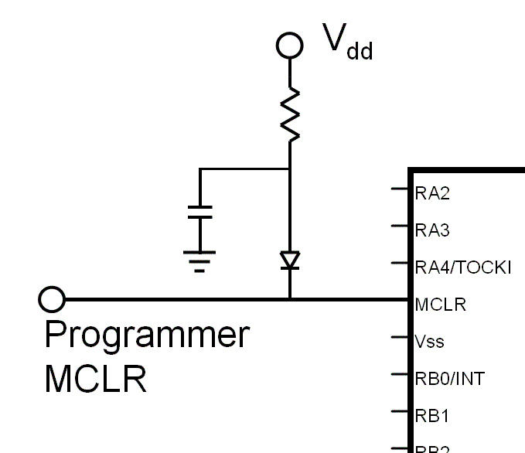  Typically, MCLR is the only signal that needs some special consideration. However, a method must be provided to isolate the programmer from the circuit when the circuit is in operate mode. The simplest technique is to simply disconnect the programmer. However, it may be more convenient to provide a switch if considerable testing is envisioned.
RB6/7 | The RB6 and RB7 signals need only be brought from the programmer to the target circuit. The target circuit must not load these two signals very heavily.
V_{dd} | If the programmer is to be disconnected to test the target circuit, it is generally more convenient to provide the programming V_{dd} supply from the programmer. Microchip recommends that the target circuit’s supply be isolated from the programmer through a low value resistor. (When operating, the PIC typically draws very little current, and can operate from voltages as low as 3 volts, so a small voltage drop is not a concern).

Implementation
Circuit | A complete circuit is shown below:  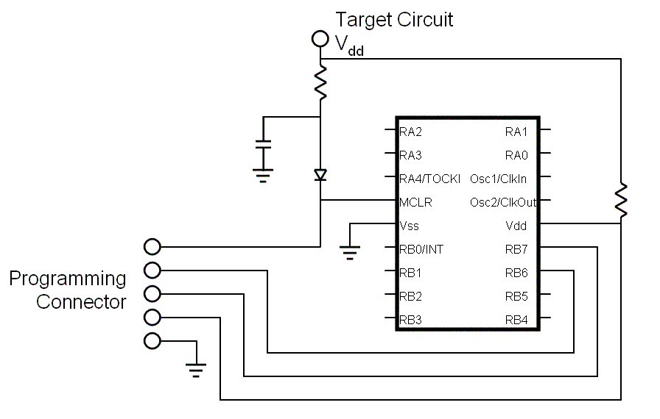
Physical Connections | Any appropriate connector may be used for the programming connector. A SIP socket is quite convenient, and has the advantage of small size. It is suggested that an additional pin be used to provide some protection against reversing the connector, especially on the target circuit side which will be frequently connected and disconnected.  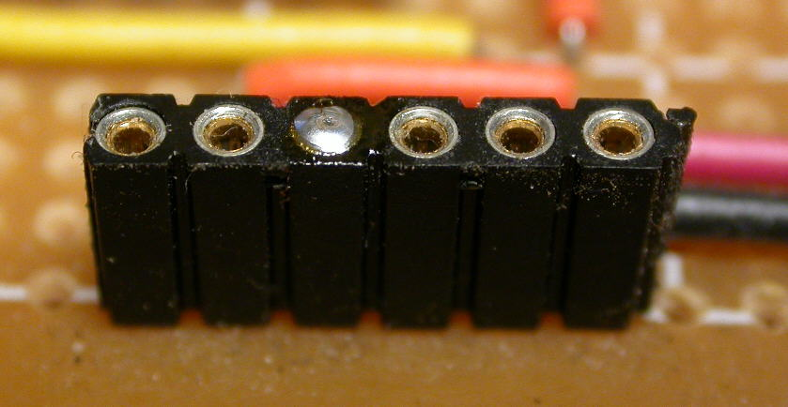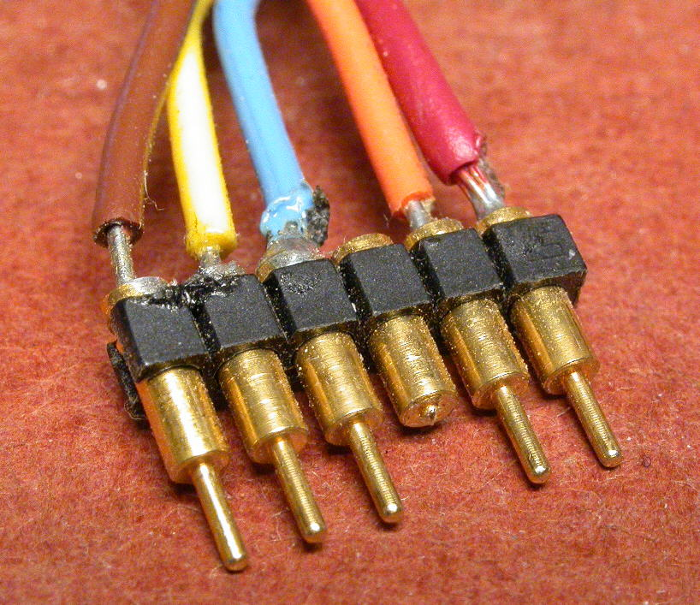  On the programmer side, the developer must use the connector provided by the programmer. If no ICSP connector is provided, the builder can use a machine pin DIP socket as a plug to connect to the programmer’s PIC socket. The less expensive tin solder tail sockets will not connect cleanly into the PIC socket and are not as durable.  